|  |  |
| --- | --- |
|  | CS 542 - Assignment 2 |
|  |  |
|  | Sukanta Sharma (A20472623), Vidya Sudharshana (A20472468), Vidhi Kakini (A20473969)  CS 542 – Computer Networks – I | Spring 2021 | Illinois Institute of Technology  5/14/21 |

# **Instructions:**

* Please submit soft copies on the blackboard.
* Team submissions are accepted. A team of 1 – 3 is accepted.
* For team submissions, one submission is sufficient. Anyone from the team can submit—no need for everyone in the group to submit.
* All should submit typewritten documents. The handwritten ones are not accepted. Zero points will be awarded if the submission is not a typewritten one.
* Please contact **Viswatej Kasapu (vkasapu@hawk.iit.edu)** if something is not clear. After submission, please do not say any excuses like "we understood differently." If you doubt any questions, please email me but do not expect me to give ideas or hints to the solution.
* **The due date is Friday, May 14, 2021, at 11:59 PM (midnight) Central Time.**
* Submissions after the due date are not accepted. This is the hard deadline. I must submit the grades to the University before the deadline. So, I cannot provide extensions to you. **Please submit before the due date without** **fail. Otherwise, zero points will be given.**

# **Instructions:**

* Please submit soft copies on the blackboard.
* For every question which has a calculation, you should show steps clearly. No points will be given for direct answers. Explanation and justification are mandatory.
* In all questions, provide answers in the decimal system (not binary, hexadecimal, or 256 bases).

1. A host with IP address 130.23.43.20 and physical address B2:34:55:10:22:10 has a packet to send to another host on another network with IP address 141.23.56.21 and physical address A4:6E:F4:59:83:AB. The next-hop (router) for this destination in the sender's routing table is Router R1 with IP address 130.23.43.25 and physical address B2:53:45:01:33:10. Give the ARP request packet format from the sender and its corresponding reply packet format filled with all necessary fields. Consider the Ethernet as hardware type and IPv4 as protocol type. **(10 points)**

Ans:

The structure of ARP Packet is given as below:



Figure : ARP Packet

## 2021st Block:

Class C addresses start with to with the first 3 bytes as Net Id and the last byte as Host Id. As the block number starts with 0, so the 2021st block will be to be added to the first address of class C.

## 2021st Block:

To find the first address of the 2021st block, we need to add to the Net Id of the first address of class C in the base-256 number system.

**Converting**  **to base-256:**

| **Divisor** | **Dividend** | **Quotient** | **Remainder** |
| --- | --- | --- | --- |
| 256 | 2020 | 7 | 228 |
| 256 | 228 | 0 | 7 |

Therefore, 🡪

To get the range of the addresses in the 2021st block class C, we must find the first and the last address of the given block.

## First Address:

To find the first address of the 2021st block, we need to add with the Net Id and the rest of the bits will be all zeros. The summation of the Net Id is given as:

| **+/-** | **Byte1** | **Byte2** | **Byte3** |
| --- | --- | --- | --- |
|  | 192 | 0 | 0 |
| + |  | 7 | 228 |
| **Result** | **192** | **7** | **228** |

With Net ID followed by zeros (0 bits), we can find the first address in the 2021st block as .

## Last Address:

As this is a class C address and the number of Host Id bits is 8, so each block will have addresses. To find the last address of the 2021st block, we need to add to the first address of the block.

| **+/-** | **Byte1** | **Byte2** | **Byte3** | **Byte4** |
| --- | --- | --- | --- | --- |
|  | 192 | 7 | 228 | 0 |
| + |  |  |  | 255 |
| **Result** | **192** | **7** | **228** | **255** |

So, the last address in the 2021st block is .

The first address is used for the network address and the last address is used for direct-broadcast addresses, so these two addresses cannot be assigned to users. Therefore, the range of addresses that can assign to users in the 2021st block of class C is .

1. Convert the number C0514019 in the hexadecimal base to the dotted-decimal notation. What is the class of this address? (consider classful addressing). (5 points)

Ans:

* Hexadecimal is a base-16 numerical system. It uses 16 distinct symbols to represent the value from 0 to 9, and to represent the value from 10 – 15. Here we will be considering per 2 digits of the hexadecimal to be equivalent to 1 byte in dotted-decimal notation and convert it to base-256 by each byte.

| **Hexadecimal** | **Conversion** | **Base-256 System** |
| --- | --- | --- |
|  |  |  |
|  | 5 |  |
|  | 4 |  |
|  | 1 |  |

The equivalent number of in dotted-decimal notation is **.**

* This address belongs to **class C.**

1. Define the 1202 block of class B? (Give first and last address in the block) (3 points)

Ans:

Class B addresses start with to with the first 2 bytes as Net Id and the last 2 bytes as Host Id. As the block number starts with 0, so the 1202nd block will be to be added to the first block of class B.

## 1202nd Block:

To find the first address of the 1202nd block, we need to add to the Net Id of the first address of class B in the base-256 number system.

**Converting**  **to base-256:**

| **Divisor** | **Dividend** | **Quotient** | **Remainder** |
| --- | --- | --- | --- |
| 256 | 2020 | 7 | 228 |
| 256 | 228 | 0 | 7 |

Therefore, 🡪

To get the range of the addresses in the 1202nd block class B, we must find the first and the last address of the given block.

## First Address:

To find the first address of the 1202nd block, we need to add with the Net Id and the rest of the bits will be all zeros. The summation of the Net Id is given as:

| **+/-** | **Byte1** | **Byte2** |
| --- | --- | --- |
|  | 128 | 0 |
| + | 4 | 177 |
| **Result** | **132** | **177** |

With Net ID followed by zeros (0 bits), we can find the first address in the 1202nd block as .

## Last Address:

As this is a class B address and the number of Host Id bits is 16, so each block will have addresses. To find the last address of the 1202nd block, we need to add to the first address of the block (i.e., ).

| **+/-** | **Byte1** | **Byte2** | **Byte3** | **Byte4** |
| --- | --- | --- | --- | --- |
|  | 132 | 177 | 0 | 0 |
| + |  |  | 255 | 255 |
| **Result** | **132** | **177** | **255** | **255** |

So, the last address in the 1202nd block is .

The range of addresses that can assign to users in the 1202nd block of class B is .

1. Convert the decimal number 5141.01568603515625 to the base 256 number system. (5 points)

Ans:

To convert to base-256 number system, we need to convert the integer part and the fraction part separately to base-256 and then we can combine them to obtain the result.

## Integer Part 🡪 :

| **Divisor** | **Dividend** | **Quotient** | **Remainder** |
| --- | --- | --- | --- |
| 256 | 5141 | 20 | 21 |
| 256 | 20 | 0 | 20 |

Therefore, 🡪

## Fraction Part 🡪 :

| **Multiplicand** | **Multiplier** | **Result** | **Integer Part** |
| --- | --- | --- | --- |
| 0.015686035 | 256 | 4.015625 | 4 |
| 0.015625 | 256 | 4 | 4 |

Therefore, 🡪 *[“,” is used as decimal point notation and “.” as a separator of base-256 digits]*

Now, concatenating both the result we can write, 🡪 *[“,” is used as decimal point notation and “.” as a separator of base-256 digits]*

1. What is the value of ? Give results in 256 base system. (Given numbers are in 256 base system) (4 points)

Ans:

## Conversion of to base-256 number system:

| **Divisor** | **Dividend** | **Quotient** | **Remainder** |
| --- | --- | --- | --- |
| 256 | 768 | 3 | 0 |
| 256 | 3 | 0 | 3 |

Therefore, is equivalent to

1. An organization is granted the block . The administrator wants to create 16 subnets.
2. Find the subnet mask (1 point).

Ans:

The block given to us is . The administrator wants to create 16 subnets. So, the number of extra bits that need to be added to the default mask is .

The subnet mask will be, *[in slash notation]* or *[in dotted-decimal notation].*

1. Find the number of addresses in each subnet (1 point)

Ans:

Here the number of bits of prefix *(same as the mask)*

The number of bits of suffix

The number address in each subnet is given by,

Therefore, the number of addresses in each subnet is  **addresses.**

1. Find the subnet address and the direct broadcast address for the first subnet. (2 points)

Ans:

## Subnet Address:

The subnet address is the **first address of the given subnet**. The first address of the first subnet is nothing but the first address of the given network, that is and the mask for this subnet is . So, the subnet address of the first block is **.**

## Direct-Broadcast Address:

The direct-broadcast address is the **last address of the given subnet**. There are addresses in each subnet. So, to find the last address of the given subnet we need to add to the first address of the subnet in the base-256 number system.

| **+/-** | **Byte1** | **Byte2** | **Byte3** | **Byte4** |
| --- | --- | --- | --- | --- |
|  | 142 | 200 | 208 | 0 |
| + |  |  |  | 127 |
| **Result** | **142** | **200** | **208** | **127** |

Therefore, the direct-broadcast address is **.**

1. Find the 4th and 99th addresses in the last subnet. (4 points)

Ans:

## 4th address:

There are addresses in each subnet. So, the 4th address of the last subnet (i.e., 16th subnet) is given by,

address

address

address

So, to get the 4th address of the 16th subnet we need to add to the first address of the network in the base-256 number system.

| **Divisor** | **Dividend** | **Quotient** | **Remainder** |
| --- | --- | --- | --- |
| 256 | 1923 | 7 | 131 |
| 256 | 3 | 0 | 7 |

Therefore, 🡪

| **+/-** | **Byte1** | **Byte2** | **Byte3** | **Byte4** |
| --- | --- | --- | --- | --- |
|  | 142 | 200 | 208 | 0 |
| + |  |  | 7 | 131 |
| **Result** | **142** | **200** | **215** | **131** |

So, the 4th address of the last subnet is

## 99th address:

There are addresses in each subnet. So, the 99th address of the last subnet (i.e., 16th subnet) is given by,

address

address

address

So, to get the 99th address of the 16th subnet we need to add to the first address of the network in the base-256 number system.

| **Divisor** | **Dividend** | **Quotient** | **Remainder** |
| --- | --- | --- | --- |
| 256 | 1923 | 7 | 226 |
| 256 | 7 | 0 | 226 |

Therefore, 🡪

| **+/-** | **Byte1** | **Byte2** | **Byte3** | **Byte4** |
| --- | --- | --- | --- | --- |
|  | 142 | 200 | 208 | 0 |
| + |  |  | 7 | 226 |
| **Result** | **142** | **200** | **215** | **226** |

So, the 99th address of the last subnet is

1. Give the mask in the dotted-decimal notation:
2. For a block of Class-A which results in 128 subnets (1 point)

Ans:

For class A, the default mask is . To have 128 subnets, it requires extra one’s bit. So, the mask, for a block of class A which results in subnets, is *[in slash notation]* or *[in dotted-decimal notation].*

1. Which combines 128 blocks of Class C into a supernet (1 point)

Ans:

For class C, the default mask is . To combine 128 blocks into a supernet, it requires less one’s bit. So, the mask, which combines blocks of class C into a supernet, is *[in slash notation]* or *[in dotted-decimal notation].*

1. Convert an IP address 254.128.64.32 to the binary notation (2 points)

Ans:

To convert the IP address to the binary notation, we need to convert each byte into binary. Then we can concatenate the binary numbers together to get the binary notation of the given IP address.

## Decimal to Binary Conversion:

| **#Byte** | **Value (in Decimal)** | **Value (in Binary)** |
| --- | --- | --- |
| 1 | 254 | 11111110 |
| 2 | 128 | 10000000 |
| 3 | 64 | 01000000 |
| 4 | 32 | 00100000 |

The equivalent IP address of in binary notation is given as,

**11111110 10000000 01000000 00100000.**

1. The 14th address of a block assigned to a specific organization is . The organization needs 120 addresses to give to its 120 users. Find the mask and define this block of addresses. Is there any wastage of the IP addresses? If yes, how many? (Note: The number of router interfaces is 2) (4 points)

Ans:

## Mask:

The organization is given a block of and it needs 120 address to give its 120 users, so the number of suffix bits is . Therefore, the mask for the block is *[in slash notation]* or *[in dotted-decimal notation]*.

## Block Definition:

To define the given block, we need to find the first and the last address of the block.

## First Address:

The 14th address of a block is . To find the first address of the block we need to subtract from the given address in the base-256 number system.

| **+/-** | **Byte1** | **Byte2** | **Byte3** | **Byte4** |
| --- | --- | --- | --- | --- |
|  | 120 | 65 | 89 | 141 |
| - |  |  |  | 13 |
| **Result** | **120** | **65** | **89** | **128** |

The first address of the block is .

## Last Address:

The mask for the block is , which means the number of prefix bits is and the number of suffix bits is . So, the total number of addresses in the block is . To find the last address we need to add to the first address of the block in the base-256 number system.

| **+/-** | **Byte1** | **Byte2** | **Byte3** | **Byte4** |
| --- | --- | --- | --- | --- |
|  | 120 | 65 | 89 | 128 |
| + |  |  |  | 127 |
| **Result** | **120** | **65** | **89** | **255** |

Therefore, the last address of the block is **.**

The given block can be defined as a block with  **addresses** and the range from **to** **.**

## IP address wasted:

The total number of addresses in the given block is . The address allocation in the organization is given by,

* **120 addresses** are given to its 120 users.
* **1 address** is used as the network address, which is the first address of the block.
* **1 address** is used as the direct-broadcast address, which is the last address of the block.
* The number of router interfaces is two, so **2 addresses** are used to identify these two interfaces.

The number of IP addresses used is and the number of addresses wasted is **.**

1. A block of addresses granted to an ISP. These addresses are allocated between two groups of customers. The first group has 20 customers, each of which needs 64 addresses, the second group has 20 customers, each of which needs 128 addresses. Show the subblocks and range of addresses for the 10th customer of the first group and the 10th customer of the second group. How many addresses are still available after this allocation? (5 points)

Ans:

From the above information, we can conclude that the address block need to be divided into the first group with subnets with 64 addresses in each subnet and subnets with addresses in each subnet.

## First Group:

There are addresses in each subnet. So, the number of suffix bits is and the prefix bits are . Therefore, the mask for each of these blocks is *[in slash notation]*.

So, the first address of the 10th customer or the 10th subnet is given by,

address

address

address

So, to get the first address of the 10th subnet we need to add to the first address of the block in the base-256 number system.

| **Divisor** | **Dividend** | **Quotient** | **Remainder** |
| --- | --- | --- | --- |
| 256 | 576 | 2 | 64 |
| 256 | 2 | 0 | 2 |

Therefore, 🡪

| **+/-** | **Byte1** | **Byte2** | **Byte3** | **Byte4** |
| --- | --- | --- | --- | --- |
|  | 120 | 200 | 240 | 0 |
| + |  |  | 2 | 64 |
| **Result** | **120** | **200** | **242** | **64** |

So, the first address of the 10th subnet is

Now, to get the last address of the 10th subnet we need to add to the first address of the subnet in the base-256 number system.

| **+/-** | **Byte1** | **Byte2** | **Byte3** | **Byte4** |
| --- | --- | --- | --- | --- |
|  | 120 | 200 | 242 | 64 |
| + |  |  |  | 63 |
| **Result** | **120** | **200** | **242** | **127** |

Therefore, the last address of this subnet is

Therefore, the subblock for the 10th customer of the first group has  **addresses** and the range of the subblock is from  **to**

## Second Group:

There are addresses in each subnet. So, the number of suffix bits is and the prefix bits are . Therefore, the mask for each of these blocks is *[in slash notation]*.

So, the first address of the 10th customer of the second group is given by,

addresses

address

address

So, to get the first address of the 10th customer we need to add to the first address of the block in the base-256 number system.

| **Divisor** | **Dividend** | **Quotient** | **Remainder** |
| --- | --- | --- | --- |
| 256 | 2432 | 9 | 128 |
| 256 | 9 | 0 | 9 |

Therefore, 🡪

| **+/-** | **Byte1** | **Byte2** | **Byte3** | **Byte4** |
| --- | --- | --- | --- | --- |
|  | 120 | 200 | 240 | 0 |
| + |  |  | 9 | 128 |
| **Result** | **120** | **200** | **249** | **128** |

So, the first address of the 10th customer in the second group is

Now, to get the last address of the 10th customer in the second group we need to add to the first address of this subnet in the base-256 number system.

| **+/-** | **Byte1** | **Byte2** | **Byte3** | **Byte4** |
| --- | --- | --- | --- | --- |
|  | 120 | 200 | 249 | 128 |
| + |  |  |  | 127 |
| **Result** | **120** | **200** | **249** | **255** |

Therefore, the last address of this subnet is

Therefore, the subblock for the 10th customer of the second group has  **addresses** and the range of the subblock is from  **to**

## Available Address:

The ISP granted the IP address with mask . So, the number of suffix bits is .

There is a total of addresses for the granted block and the total number address used is given by,

addresses

addresses

Therefore, there are  **addresses**  still available after this allocation.

1. Find first address, last address, and number of addresses in the block, if one of the addresses in a block is (3 points)

Ans:

## First Address:

To find the first address or network address we need to perform a logical **AND** operation between the given IP address and the mask. As the mask is , so we can perform this **AND** operation with the left 4 bits of the third byte from the left. The third byte is given as or .

Now,

In the network address first 16 bits will be the same as the address given *(i.e., ),* the third byte is and the rest of the bits will be all zeros.

Therefore, the network address or the first address is **.**

## Last Address:

One of the addresses in a block is given as . So, the number of suffix bits is . The number of suffix bits is . So, the total number of addresses is . To find the last address we need to add to the first address of the block in the base-256 number system.

| **Divisor** | **Dividend** | **Quotient** | **Remainder** |
| --- | --- | --- | --- |
| 256 | 4096 | 15 | 255 |
| 256 | 15 | 0 | 15 |

Therefore, 🡪

| **+/-** | **Byte1** | **Byte2** | **Byte3** | **Byte4** |
| --- | --- | --- | --- | --- |
|  | 140 | 240 | 80 | 0 |
| + |  |  | 15 | 255 |
| **Result** | **140** | **240** | **95** | **255** |

So, the last address of the block is

## Number of Addresses:

One of the addresses in a block is given as . So, the number of suffix bits is . The number of suffix bits is . So, the total number of addresses is **.**

1. Consider the following routing table (the next-hop address is omitted):

| **Mask** | **Network Address** | **Interface** |
| --- | --- | --- |
| /27 | 144.56.55.0 | M0 |
| /26 | 123.80.97.0 | M1 |
| /25 | 123.80.97.128 | M2 |
| /24 | 118.114.132.0 | M3 |
| Default | Default | M4 |

Give the interface number for a packet whose destination IP address is:

1. 144.56.55.31 (1 point)

Ans:

To find the network address of the given IP address, we need to apply the masks in descending order. If the resultant network address is found, then the corresponding interface is chosen and if the resultant network address cannot be found in the routing table the default interface is chosen.

The masks are applied as given below:

| **Destination IP Address** | **Mask** | **IP Address in binary (only in the last byte) [A]** | **Mask in binary (only in the last byte) [B]** | **[A] AND [B]** | **Network Address** |
| --- | --- | --- | --- | --- | --- |
| 144.56.55.31 | /27 | 3110 🡪 000101112 | 111000002 | 00000000­2 🡪 010 | 144.56.55.0 |

As the resultant network address for mask is found in the routing table, so the interface number chosen is **M0**.

1. 144.56.56.31 (1 point)

Ans:

The masks are applied as given below:

| **Destination IP Address** | **Mask** | **IP Address in binary (only in the last byte) [A]** | **Mask in binary (only in the last byte) [B]** | **[A] AND [B]** | **Network Address** |
| --- | --- | --- | --- | --- | --- |
| 144.56.56.31 | /27 | 3110 🡪 000101112 | 111000002 | 00000000­2 🡪 010 | 144.56.56.0 |
| 144.56.56.31 | /26 | 3110 🡪 000101112 | 110000002 | 00000000­2 🡪 010 | 144.56.56.0 |
| 144.56.56.31 | /25 | 3110 🡪 000101112 | 100000002 | 00000000­2 🡪 010 | 144.56.56.0 |
| 144.56.56.31 | /24 | 3110 🡪 000101112 | 000000002 | 00000000­2 🡪 010 | 144.56.56.0 |

As the resultant network address for all masks is not found in the routing table, so the interface number chosen is **M4**.

1. 123.80.97.60 (1 point)

Ans:

The masks are applied as given below:

| **Destination IP Address** | **Mask** | **IP Address in binary (only in the last byte) [A]** | **Mask in binary (only in the last byte) [B]** | **[A] AND [B]** | **Network Address** |
| --- | --- | --- | --- | --- | --- |
| 123.80.97.60 | /27 | 6010 🡪 001111002 | 111000002 | 00100000­2 🡪 3210 | 123.80.97.32 |
| 123.80.97.60 | /26 | 6010 🡪 001111002 | 110000002 | 00000000­2 🡪 010 | 123.80.97.0 |

As the resultant network address for mask is found in the routing table, so the interface number chosen is **M1**.

1. 123.80.97.200 (1 point)

Ans:

The masks are applied as given below:

| **Destination IP Address** | **Mask** | **IP Address in binary (only in the last byte) [A]** | **Mask in binary (only in the last byte) [B]** | **[A] AND [B]** | **Network Address** |
| --- | --- | --- | --- | --- | --- |
| 123.80.97.200 | /27 | 20010 🡪 110010002 | 111000002 | 11000000­2 🡪 19210 | 123.80.97.192 |
| 123.80.97.200 | /26 | 20010 🡪 110010002 | 110000002 | 11000000­2 🡪 19210 | 123.80.97.192 |
| 123.80.97.200 | /25 | 20010 🡪 110010002 | 100000002 | 10000000­2 🡪 12810 | 123.80.97.128 |

As the resultant network address for mask is found in the routing table, so the interface number chosen is **M2.**

1. 123.80.97.88 (1 point)

Ans:

The masks are applied as given below:

| **Destination IP Address** | **Mask** | **IP Address in binary (only in the last byte) [A]** | **Mask in binary (only in the last byte) [B]** | **[A] AND [B]** | **Network Address** |
| --- | --- | --- | --- | --- | --- |
| 123.80.97.88 | /27 | 8810 🡪 010110002 | 111000002 | 01000000­2 🡪 6410 | 123.80.97.64 |
| 123.80.97.88 | /26 | 8810 🡪 010110002 | 110000002 | 01000000­2 🡪 6410 | 123.80.97.64 |
| 123.80.97.88 | /25 | 8810 🡪 010110002 | 100000002 | 00000000­2 🡪 010 | 123.80.97.0 |
| 123.80.97.88 | /24 | 8810 🡪 010110002 | 000000002 | 00000000­2 🡪 010 | 123.80.97.0 |

As the resultant network address for all masks is not found in the routing table, so the interface number chosen is **M4**.

1. 118.114.133.1 (1 point)

Ans:

The masks are applied as given below:

| **Destination IP Address** | **Mask** | **IP Address in binary (only in the last byte) [A]** | **Mask in binary (only in the last byte) [B]** | **[A] AND [B]** | **Network Address** |
| --- | --- | --- | --- | --- | --- |
| 118.114.133.1 | /27 | 110 🡪 000000012 | 111000002 | 00000000­2 🡪 010 | 118.114.133.0 |
| 118.114.133.1 | /26 | 110 🡪 000000012 | 110000002 | 00000000­2 🡪 010 | 118.114.133.0 |
| 118.114.133.1 | /25 | 110 🡪 000000012 | 100000002 | 00000000­2 🡪 010 | 118.114.133.0 |
| 118.114.133.1 | /24 | 110 🡪 000000012 | 000000002 | 00000000­2 🡪 010 | 118.114.133.0 |

As the resultant network address for all masks is not found in the routing table, so the interface number chosen is **M4**.

1. The routing table of routers R1, R2, and R3 are given. Draw the possible network configuration with all 3 routers, not separate configurations corresponding to each routing table. Indicate the next-hop addresses in the figure. (10 points)

R1:

| **Mask** | **Network Address** | **Next-Hop Address** | **Interface Number** |
| --- | --- | --- | --- |
| /24 | 80.70.56.0 | 100.160.32.67 | M2 |
| /24 | 130.135.7.0 | 150.137.45.78 | M1 |
| /16 | 180.170.0.0 | ----------------- | M0 |
| /16 | 100.160.0.0 | ----------------- | M2 |
| /16 | 150.137.0.0 | ----------------- | M1 |
| Default | Default | 180.170.4.6 | M0 |

R2:

| **Mask** | **Network Address** | **Next-Hop Address** | **Interface Number** |
| --- | --- | --- | --- |
| /24 | 80.70.56.0 | ----------------- | M0 |
| /16 | 100.160.0.0 | ----------------- | M1 |
| Default | Default | 100.160.56.7 | M1 |

R3:

| **Mask** | **Network Address** | **Next-Hop Address** | **Interface Number** |
| --- | --- | --- | --- |
| /24 | 130.135.7.0 | ----------------- | M0 |
| /16 | 150.137.0.0 | ----------------- | M1 |
| Default | Default | 150.137.72.48 | M1 |

Ans:

Considering the above routing tables for R1, R2, and R3, the possible network configuration diagram with all 3 routers is shown as below:

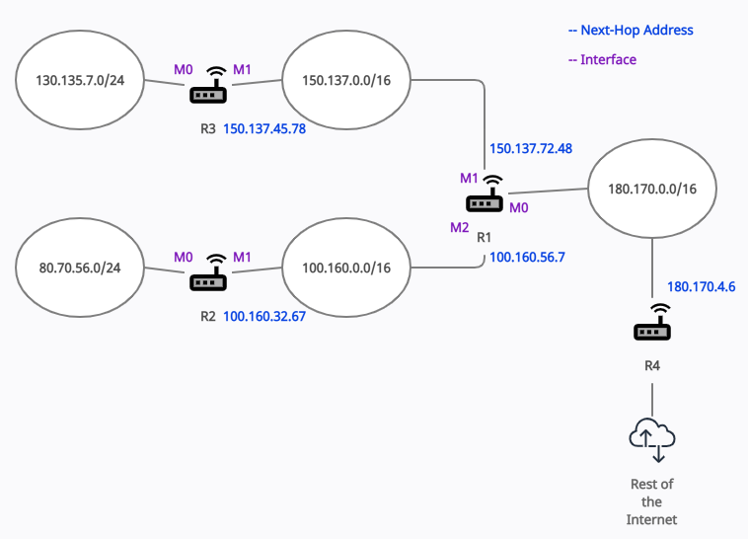

Figure : Network Diagram

1. Consider the network configuration below. A packet arrived at the router R3 with the destination address . Show how it is forwarded. (Assume classless addressing and mask of each network is ) Create a routing table for R1 and R3. (10 points)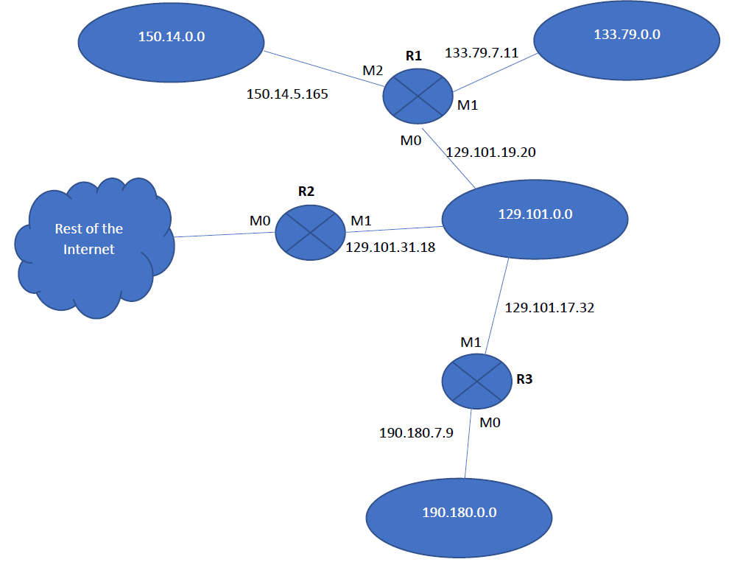Ans:

The routing table is given as below:

## The routing table for router R1:

| **Mask** | **Network Address** | **Next-Hop Address** | **Interface Number** |
| --- | --- | --- | --- |
| /24 | 150.14.0.0 | ----------------- | M2 |
| /24 | 133.79.0.0 | ----------------- | M1 |
| /24 | 129.101.0.0 | ----------------- | M0 |
| /24 | 192.180.0.0 | 129.101.17.32 | M0 |
| Default | Default | 129.101.31.18 | M0 |

## The routing table for router R2:

| **Mask** | **Network Address** | **Next-Hop Address** | **Interface Number** |
| --- | --- | --- | --- |
| /24 | 150.14.0.0 | 129.101.19.20 | M1 |
| /24 | 133.79.0.0 | 129.101.19.20 | M1 |
| /24 | 190.180.7.9 | 129.101.19.20 | M1 |
| /24 | 129.101.0.0 | ----------------- | M1 |
| Default | Default | ----------------- | M0 |

## The routing table for router R3:

| **Mask** | **Network Address** | **Next-Hop Address** | **Interface Number** |
| --- | --- | --- | --- |
| /24 | 190.180.0.0 | ----------------- | M0 |
| /24 | 129.101.0.0 | ----------------- | M1 |
| /24 | 150.14.0.0 | 129.101.19.20 | M1 |
| /24 | 133.79.0.0 | 129.101.19.20 | M1 |
| Default | Default | 129.101.31.18 | M1 |

## Packet Forwarding:

The packet is at router R3 with destination address as *[in dotted-decimal notation]* or *[in binary notation]*. The mask is given as . The network address is extracted by masking off the leftmost bits of the destination address; the result is **.** The resultant network does not match with any entry in the routing table of router R3, so the default entry is chosen. The next-hop address and the interface **M1** are passed to ARP. After this, the packet is forwarded to router **R2.**

Now, the packet is at router R2 with destination address as *[in dotted-decimal notation]* or *[in binary notation]*. The mask is given as . The network address is extracted by masking off the leftmost bits of the destination address; the result is **.** The resultant network does not match with any entry in the routing table of router R3, so the default entry is chosen. The interface **M0** is passed to ARP. After this, the packet is forwarded to the **Rest of the Internet.**